McKinsey 7S Model – Practical Application Worksheet

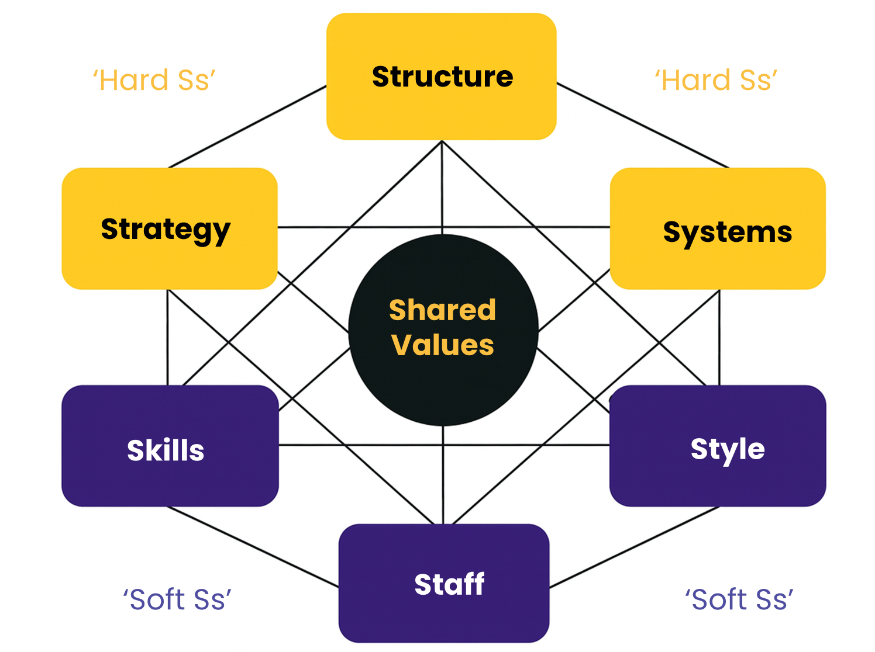

1. Identify Misalignment
Which of the seven elements (Strategy, Structure, Systems, Skills, Staff, Style, Shared Values) feels out of sync in your organisation right now?
Notes:

2. Choose the Most Impactful Element
If you could improve just ONE of the seven elements, which would have the greatest positive impact—and why?
Notes:

3. Explore Interdependencies
If one element changes (e.g., Strategy), what other elements would also need to shift to stay aligned?
Notes:

4. Assess Shared Values
How well do your organisation’s Shared Values show up in day‑to‑day behaviours, decisions, and systems?
Notes:

5. Plan Immediate Action
What is one small, concrete action you could take next week to strengthen alignment across the 7S model?
Notes:

McKinsey 7S Change Model – Understanding the 7 Key Elements

McKinsey 7S Change Model reminds us that organisations don’t work like machines where you can replace one part and everything still runs smoothly. Organisations work more like ecosystems — everything is connected.
How to Apply it:
If one element changes, the others will be affected — so successful change means aligning all seven.
Shared Values sit right at the centre because culture and purpose ultimately shape how everything else works.
By using this model, we can diagnose:
- where things are misaligned,
- understand why change isn’t sticking, and
- identify where we need to focus our efforts
Understanding the 7 key elements:
1. Strategy (Hard S)
What it is:
The organisation’s plan for achieving its goals and gaining advantage in its environment.
Key focus:
- Where are we trying to go?
- How will we compete or succeed?
- What choices are we making (and not making)?
In change:
If the strategy shifts but nothing else does, people keep working in old ways and the strategy fails.
Typical misalignment sign:
Clear strategy on paper, but teams don’t understand priorities or trade-offs.

2. Structure (Hard S)
What it is:
How the organisation is organised — reporting lines, roles, responsibilities, and accountability.
Key focus:
- Who reports to whom?
- How are teams grouped?
- Where are decisions made?
In change:
Old structures can block new ways of working, even when intentions are good.
Typical misalignment sign:
People are asked to collaborate, but incentives and reporting lines reward silos.

3. Systems (Hard S)
What it is:
The formal and informal processes that keep the organisation running day to day.
Key focus:
- IT systems
- Performance management
- Budgeting, approvals, workflows
- Policies and procedures
In change:
If systems don’t change, behaviour usually won’t either.
Typical misalignment sign:
New behaviours are encouraged, but systems still measure or reward the old ones.

4. Shared Values (Centre of the model)
What it is:
The organisation’s core beliefs, culture, and what really matters — often unspoken.
Key focus:
- “How we do things around here”
- What gets praised or punished
- What leaders truly value under pressure
In change:
Shared Values sit at the centre because they shape every other S.
Typical misalignment sign:
Change initiatives clash with deeply held cultural norms.

5. Skills (Soft S)
What it is:
The capabilities and competencies that exist in the organisation.
Key focus:
- What are we good at?
- What skills are missing?
- What needs to be developed for the future?
In change:
You can’t expect new outcomes without building new skills.
Typical misalignment sign:
People are expected to work differently without training or support.

6. Staff (Soft S)
What it is:
The people themselves — numbers, roles, demographics, motivations, and wellbeing.
Key focus:
- Who do we have?
- Do we have the right people in the right roles?
- How are people supported through change?
In change:
Ignoring the human impact leads to resistance, burnout, or disengagement.
Typical misalignment sign:
Change plans exist, but workload, morale, or capability issues are ignored.

7. Style (Soft S)
What it is:
How leaders and managers actually behave — not what they say.
Key focus:
- Leadership approach
- Decision-making style
- How leaders act under pressure
- What behaviour is role-modelled
In change:
People copy leaders. Style either accelerates or silently kills change.
Typical misalignment sign:
Leaders talk about empowerment but continue to micromanage.

How to use the model in practice
- Treat the organisation like an ecosystem, not a machine
- Use the 7S model to (see practical application worksheet above to guide you through the various layers):
  - Diagnose misalignment
  - Understand why change isn’t sticking
  - Decide where to intervene first
Key takeaway:
Successful change happens when all seven elements are aligned — not when one is “fixed” in isolation.

